# **Task 4 P: Computer Vision**

## **Introduction**

## Computer vision is a field of computer science and AI that teaches computers to identify and comprehend objects and people in images and videos. It uses artificial intelligence (AI) and machine learning (ML) to process data from devices like smartphones, security systems, and traffic cameras to identify objects, classify, recommend, monitor, and detect.

Some technique computer vision includes:

* Image processing and transformation
* Feature extraction and description
* Deep learning for computer vision
* Image segmentation
* 3D reconstruction
* Objects detection and recognition

## **Pre-requisites**

In this case study we will be using Azure computer vision service using Azure Cognitive Services SDK. Before start coding will be doing some set-ups:

1. Resource Group set-up:

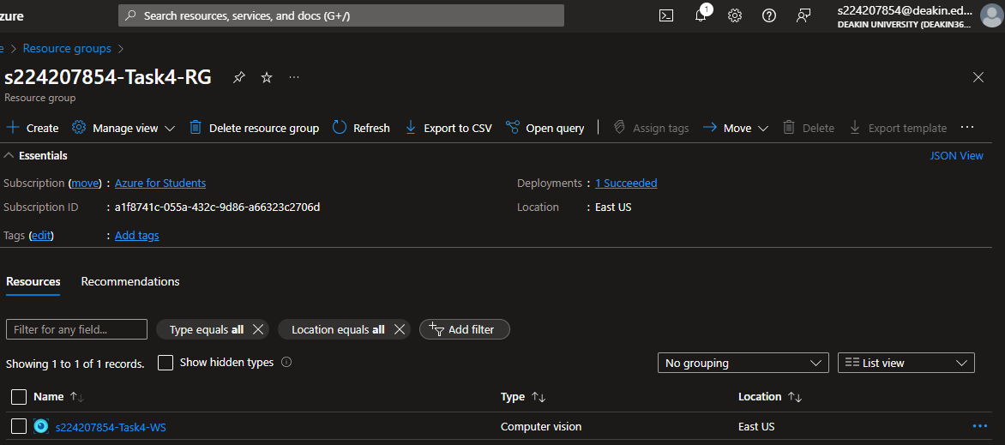

1. Creating computer vision service in Azure AI services

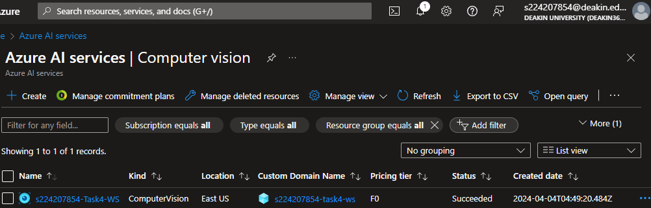

1. In Azure AI service we can visit our Computer Vision

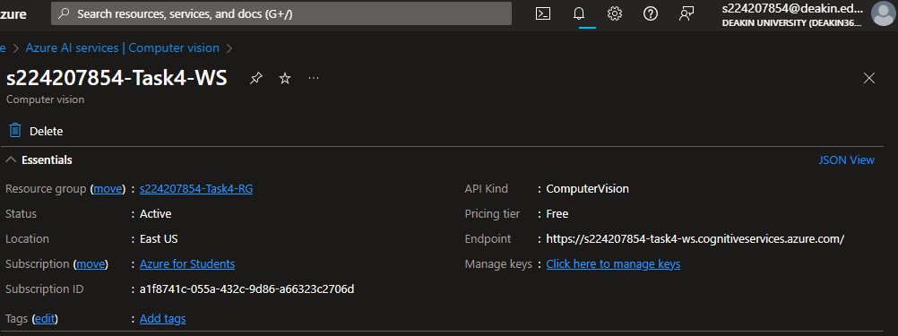

1. Installing Azure SDK using pip



1. Setting up Azure Computer Vision service client using subscription key and endpoint

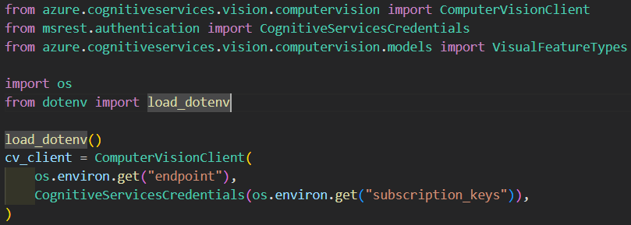

1. Once computer vision client is set-up, we can use different services provided with this client for our further analysis.

## **Azure Computer Vision Notebook**

In our notebook we will be using azure computer vision client to analyze different images as input with visual features as ‘Tags’, ‘Brands’ and ‘Objects’. On the basis of these different features, we will be providing output with different data.

In the below code snippet, 3 APIs have been invoked, i.e.:

* Feature tagging, where different tags are applied based on a set of thousands of recognizable objects.
* Object detection, where commons objects are detected and bounding box is created over the coordinates.
* Brand detection, where logos are identified from the image.

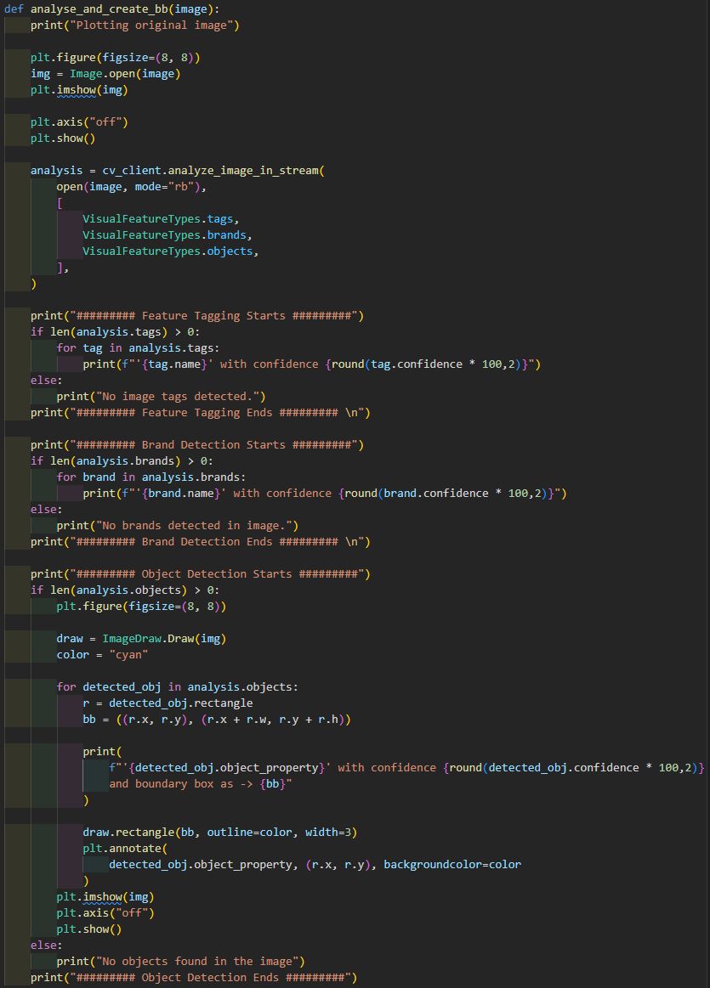

## **Testing**

### Image Test-1

* Plotting Original Image

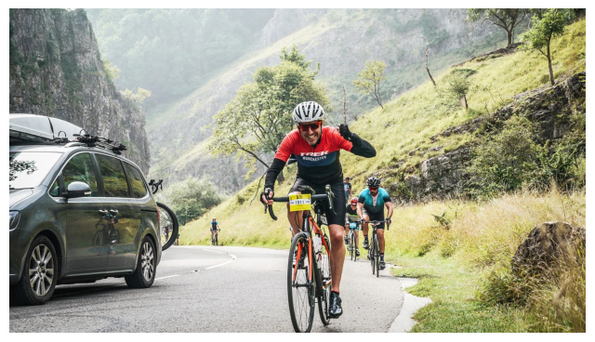

* Feature Tagging:

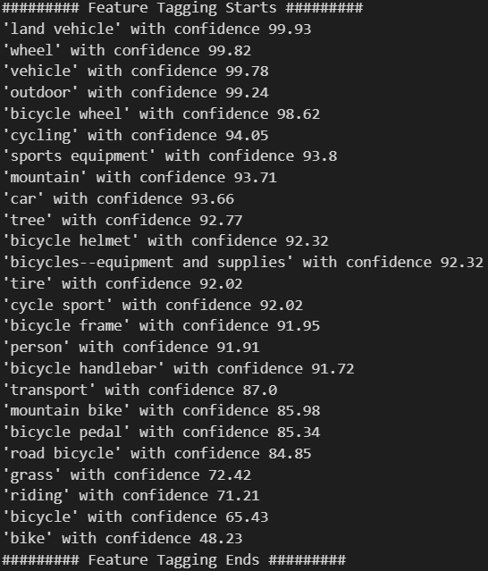

* Object Detection:

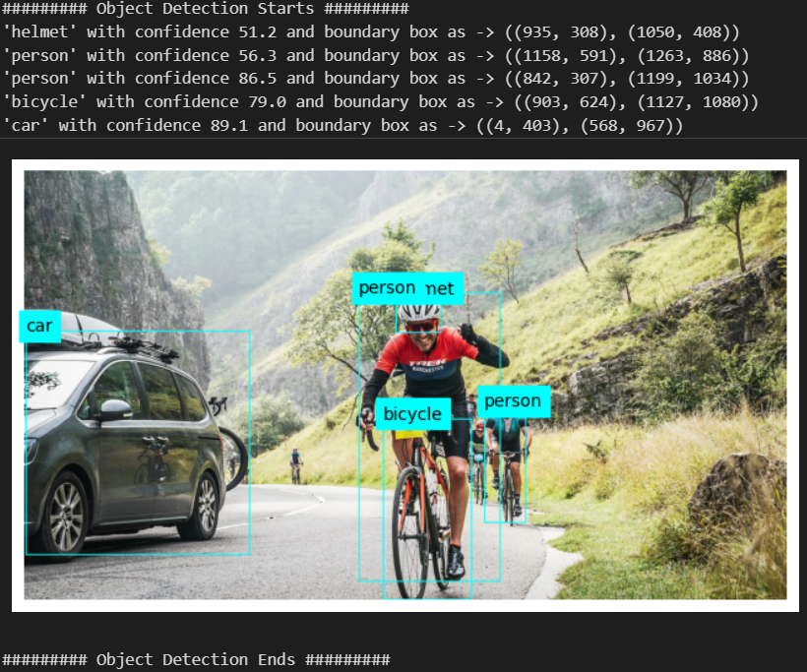

### Image Test-2

* Plotting Original Image

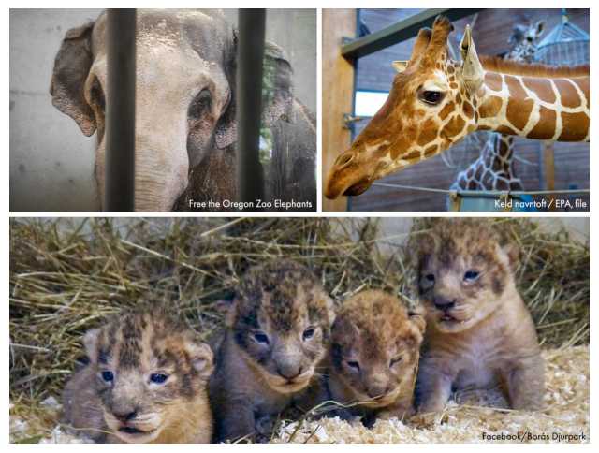

* Feature Tagging:

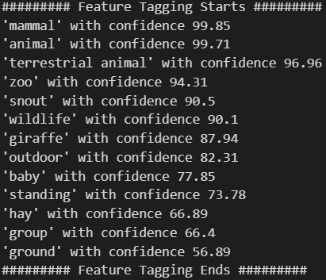

* Object Detection:

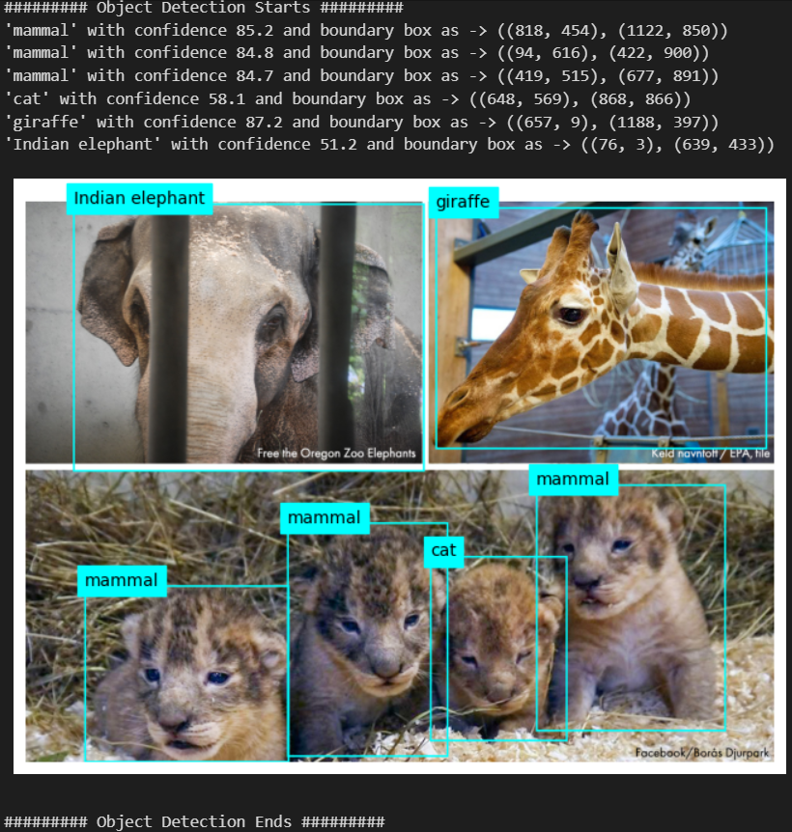

### Image Test-3

* Plotting Original Image

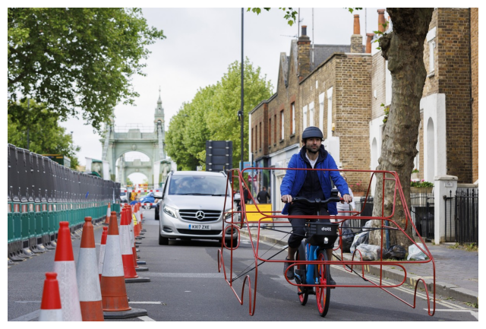

* Feature Tagging:­

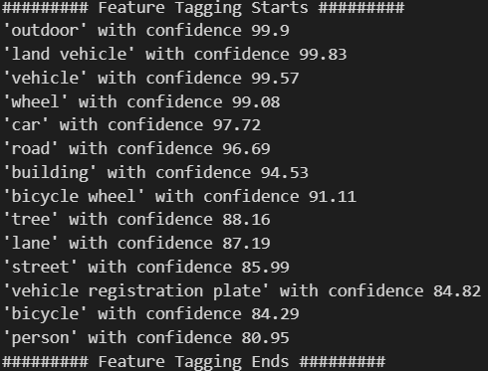

* Object Detection:

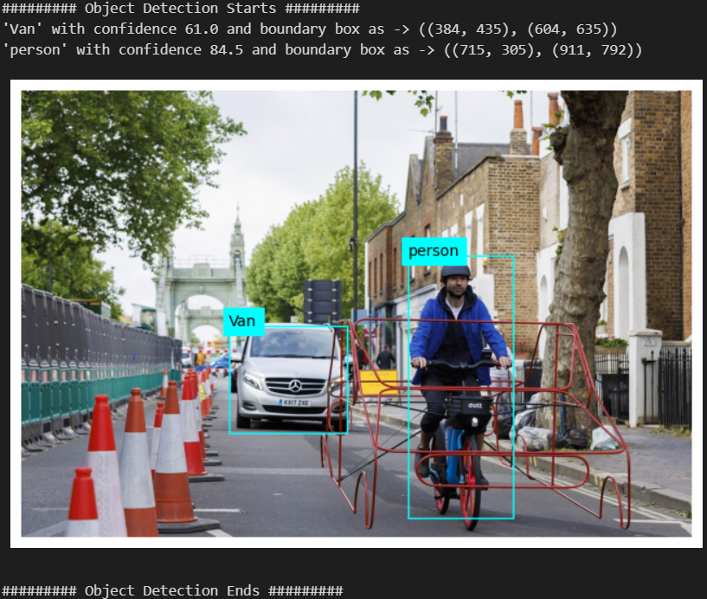

### Image Test-4

* Plotting Original Image

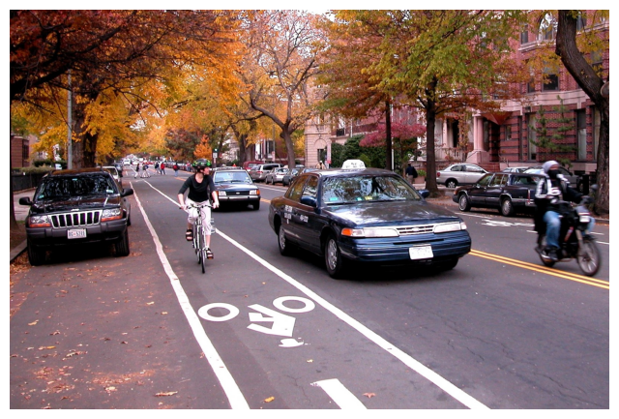

* Feature Tagging:

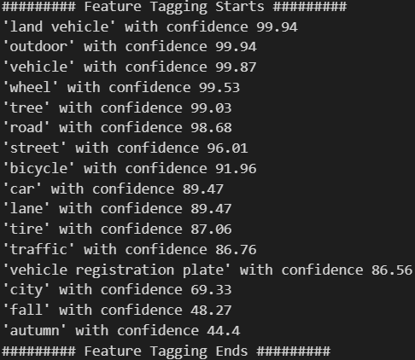

* Object Detection:

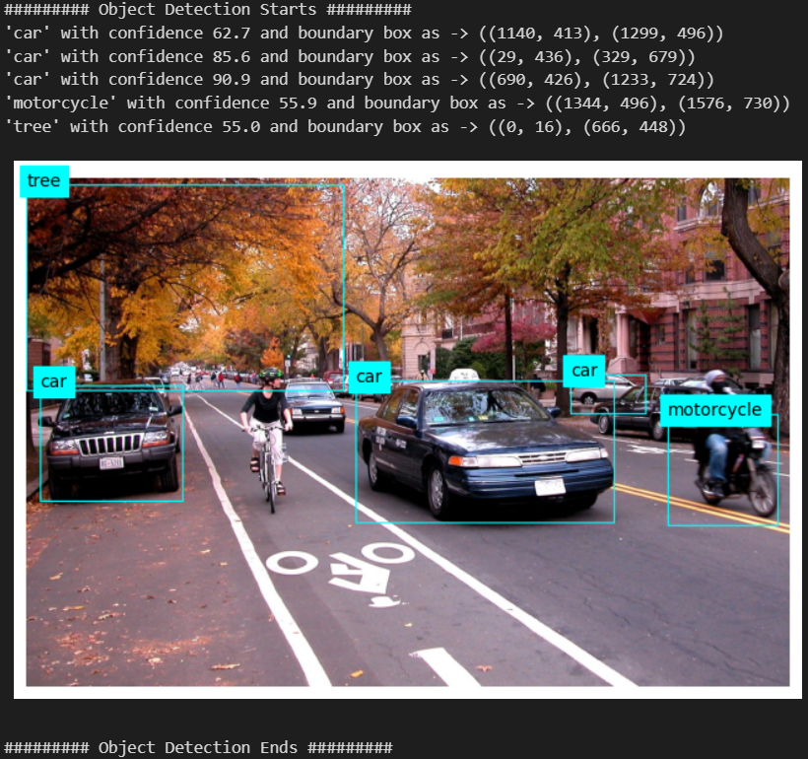

## **Summary**

In this task we have learnt about computer vision and the usage of Azure with computer vision. Using pre-defined libraries and models to predict and discover the object from image.

Still there are some objects that aren’t getting detected, we can make our own model for this purpose so that we can get an appropriate accuracy with higher performance.

## **References**

* <https://olympus.mygreatlearning.com/courses/109578?module_id=747612>
* <https://learn.microsoft.com/en-us/azure/ai-services/computer-vision/overview>
* Different google surfing.